State of New Jersey

Emergency Medical Dispatch Guidecards
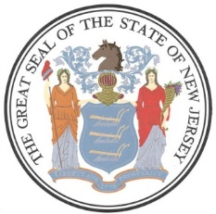
November 18, 2022
ALERTS

EBOLA 2022

2019 Novel Coronavirus

Approved by: State of New Jersey Department of Health, Office of Emergency Medical Services http://www.state.nj.us/health/ems

Adopted by:

State of New Jersey, Office of Information Technology, Office of Emergency Telecommunications Services
http://www.nj.gov/911
State of New Jersey EMD Guidecards Version 11/18
C
U
R
R
E
N
T

Ebola
Look for recent travel (up to 21 days) in affected areas. GO TO: ALERT # 2022—11-18-1 EBOLA PROTOCAL CARD
Current outbreaks reported in West Africa.
Ebola in Uganda - Alert - Level 2, Practice Enhanced Precautions - Travel Health Notices | Travelers' Health | CDC

2019 Novel Coronavirus
For patients who are short of breath/have a fever/are coughing AND travelled outside the United States within the past two weeks, please alert responders that the patient may have a “Possible Infectious Respiratory Illness” and to use contact and respiratory precautions.
Interim Guidance
https://www.cdc.gov/coronavirus/2019-ncov/hcp/guidance-for-ems.html

Prompts Short Report
Pre-Arrival Instructions
ALERTS

D
I
S
P
A
T
C
H
If a more detailed interrogation is needed go to:

If PSAP call takers advise that the patient is suspected of having 2019-nCoV, ADVISE ALL RESPONDERS (Police, Fire, EMS, any others directly or through their dispatch)TO USE P.P.E.
Anyone from the general public with questions should be instructed to call
The Hotline 1-800-222-1222 (NJ Poison Control)

